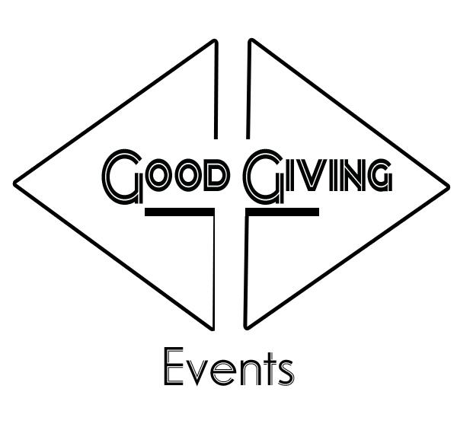

MAKE A DIFFERENCE!
_____________________________________________________________________________
Sponsoring a Good Giving Event provides you the unique opportunity to connect with the Artists and Business Owners in the Los Angeles community, to build brand awareness and show your company’s support of an important cause: The Youth & The Arts! Each event reaches a different key audience segment and provides a fun, entertaining and engaging way for you to “wow” clients, vendors and employees. Feel good about supporting our local arts, heritage and cultural organizations as you enjoy an unforgettable event. We will also be donating a portion of the proceeds to a local non-profit calle ‘A Place Called Home’

A PLACE CALLED HOME
_____________________________________________________________________________
A Place Called Home is a safe haven in South Central Los Angeles where underserved youth are empowered to take ownership of the quality and direction of their lives through programs in education, arts, and well-being and are inspired to make a meaningful difference in their community and the world.
http://www.apch.org/

ABOUT THE EVENT
____________________________________________________________________________
Each year, 20 Female Entertainers, 10 Visual Artists, an array of Vendors gather at the Good Giving Event at Leimert Park Art Walk, called “The Isis Invitational:Celebrating Art & Strength in Women” . Listen to the sounds of over six different Genre’s of Music in the region and dozens of different fashion, food and art vendors from around the State of California as you enjoy the festive atmosphere. We will be Honoring the founder of A Place Called Home, Ms Debra, and will be accepting donation for their programs.
Address: 4343 Leimert Blvd. Los Angeles, Ca
Date: Sunday March 29, 2015
Time: 3:00 pm - 8:00 pm
Entry: Free
Attendees: 300+
MEDIA REACH
____________________________________________________________________________
This event provides wide exposure through a variety of media outlets and marketing channels. Please use the table below as a basic guide of the types of advertising, public and community relations opportunities afforded by an event sponsorship.* *Refer to your sponsor contract for specific recognition opportunities and requirements. Each sponsor should provide a high-quality color and black-and-white logo (.EPS or vector logos preferred) to Good Giving with appropriate time to meet print and placement deadlines. Final pieces will be presented for sponsor approval before going to print.

Media Outlets

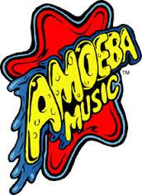

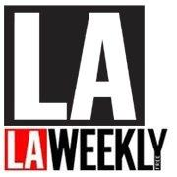

SPONSORSHIP OPPORTUNITIES
______________________________________________________________________________
Diamond Sponsor........................................................................................................... $2,000
Benefits:
•Prominent sponsor recognition on all event-related marketing & promotional collateral: invitations, e-mails and posters
•Sponsor listing on all event signage and event program
•Sponsor recognition and link from the event page on the Good Giving web site
•Full Size Exclusive Booth Space at the event
•Opportunity to provide marketing materials and giveaways for attendee gift bags
•Company name mentioned during the program and in all media advertising: print and online
•Full Page Advertising for Sponsor advertisement in event program
•Opportunity to speak to attendees during the program
Gold Sponsor........................................................................................................... $1,000
Benefits:
•Prominent sponsor recognition on all event-related marketing & promotional collateral: postcard, flyers, e-mails and posters
•Sponsor listing on all at-event signage and event program
•Half Page Advertising for Sponsor advertisement in event program
•Sponsor recognition and link from the event page on the Good Giving web site
•Space at Sponsors Info Table at the event
•Opportunity to provide marketing materials and giveaways for attendee gift bags
•Company name mentioned in all media advertising: print, online and radio
Ruby Sponsor............................................................................................................ $750
Benefits:
•Sponsor recognition on all event-related marketing & promotional collateral: postcard, flyers, e-mails and posters.
•Sponsor listing on select at-event signage
•Sponsor recognition and link from the event page on the Good Giving web site
•Quarter Page Advertising for Sponsor advertisement in event program
•Opportunity to provide marketing materials and giveaways for attendee gift bags
Emerald Sponsor.....................................................................................................................$500 Benefits:
•Sponsor recognition on select at-event signage
•Sponsor recognition on the event page on the Good Giving web site
•Opportunity to provide marketing materials and giveaways for attendee gift bags
Pearl Sponsor ................................................................................................................. $250
Benefits:
•Sponsor recognition on select at-event signage and in the event program, flyers, posters, and other promotional tools
•Sponsor recognition on the event page on the Good Giving Events web site
•Opportunity to provide marketing materials and giveaways for attendee gift bags

SPONSORSHIP FORM
______________________________________________________________________________
Please fill-out the following form to confirm your chosen sponsorship package. Completed forms can be returned to Ashley-Dominique Green, Events Manager, at GoodGiving.Info@Gmail.Com or by PayPal (An Email Confirmation Will Be Sent With PayPal Access Info). Please contact us with any questions.

CONTACT INFORMATION:
_____________________________________________________________________________
Company Name & Contact Person _________________________________________________
Contact E-mail & Contact Phone Number____________________________________________ Address City/State/Zip Code ______________________________________________________

SPONSORSHIP PACKAGES:
_________________________________________________________________________
Diamond Package ____ $3,000
Gold Sponsor ____ $2,000
Ruby Sponsor ____ $1,000
Emerald Sponsor ____ $500
Pearl Sponsor ____ $250
Final Date for Sponsor Response (not payment) is Friday March 6th
Final Date for Payment is Monday March 16th

PAYMENT INFORMATION:
_____________________________________________________________________________
____ Please send me an invoice
____ I have enclosed a check made payable to the Greater Hartford Arts Council
____ Please charge my credit card Card Type: Visa / MC / AmEx / Discover _______________________________________________ Card Number _______________________________________________ Expiration Date
________________________________________________ Security Code
________________________________________ ___________
Signature Date

Once we receive your completed sponsorship form, our staff will contact you to discuss event arrangements, sponsorship benefits and recognition. Please send your high resolution color and black -and-white logos to GoodGiving.Info@gmail.com All materials will be sent for your approval before going to print.

Good Giving Events
EIN # 46-3616029
Employer Identification Number (EIN) is also known as a Federal Tax Identification Number, and is used to identify a business entity

